

**DEPARTMENT OF COMPUTING**

**ISYS224 2019 S2 – ASSIGNMENT ONE (25%)**

**Due: 6pm Friday 13 September 201****9 (Week 7)**

**Database Design & Implementation**

Please Print Clearly In **CAPITALS**

|  |  |
| --- | --- |
| **Surname** | **DE MASI** |
| **First Name** | **MATTHEW** |
| **Student ID** | **45585342** |
| **Signature** |  |

#### **Student Code of Conduct**

Macquarie University students have a responsibility to be familiar with the Student Code of Conduct: [https://students.mq.edu.au/study/getting-started/student-conduct​](https://students.mq.edu.au/study/getting-started/student-conduct)

### Student Support

Macquarie University provides a range of support services for students. For details, visit <http://students.mq.edu.au/support/>

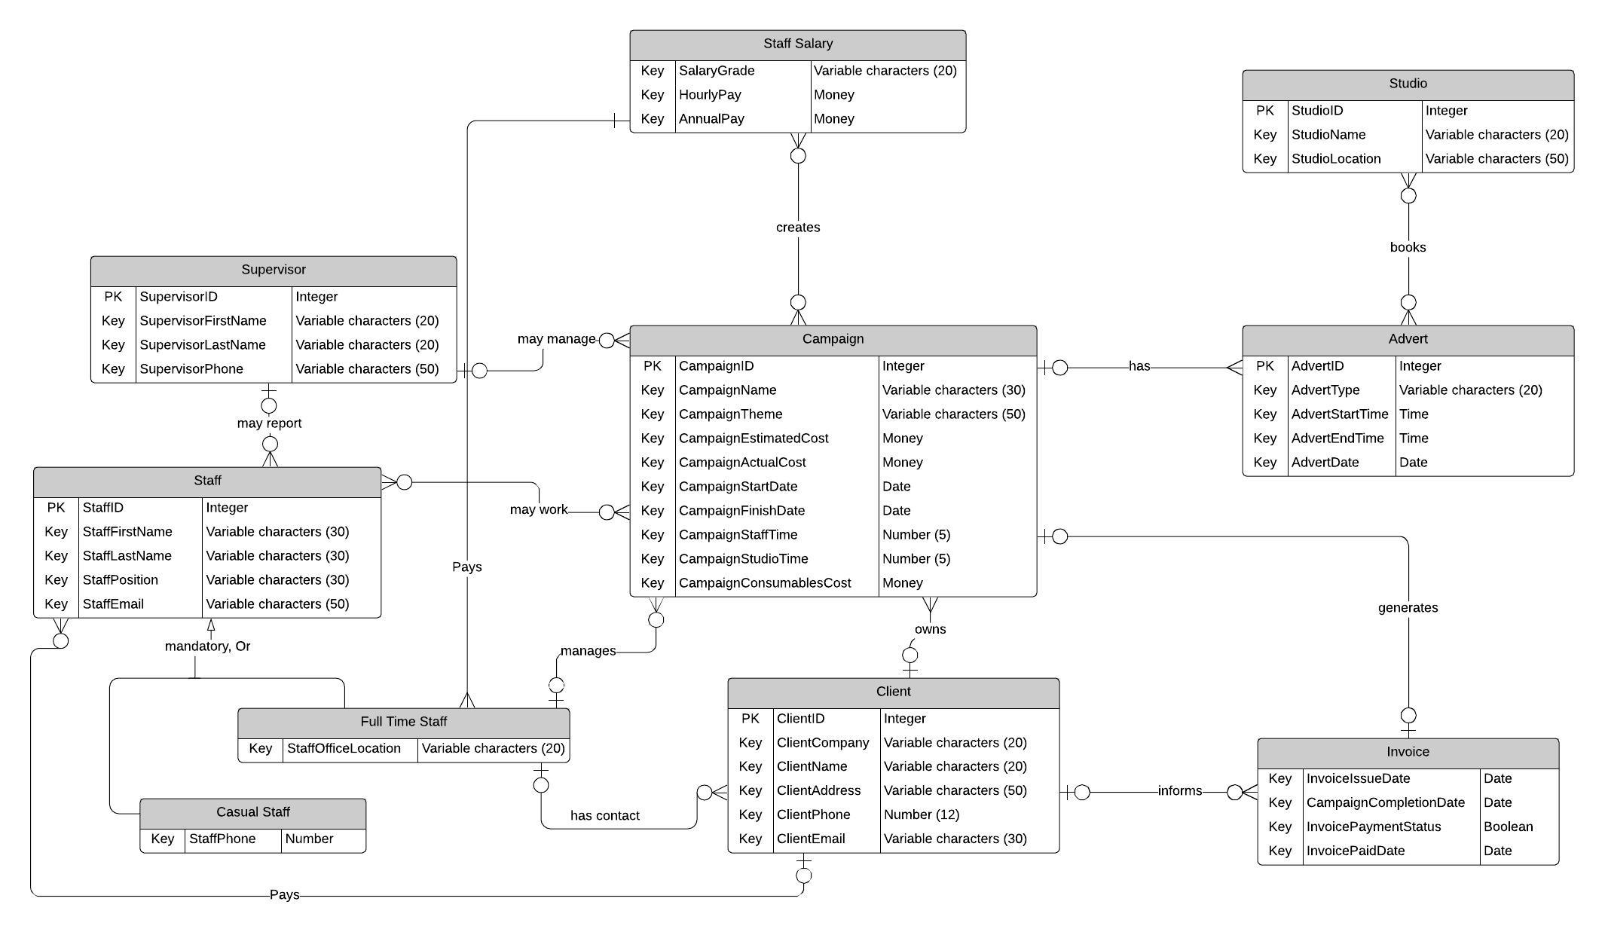**Task 1: Conceptual data model**

**Relationships: (13)**

1 – Many to Many relationships between Staff Salary and Campaign

2 – Many to One relationship between Supervisor and Staff

3 – Many to Many relationships between staff and campaign

4 – Many to One relationship between advert and campaign

5 – One to One relationship between campaign and invoice

6 – Many to One relationship between invoice and client

7 – Many to Many relationship between advert and studio

8 – One to Many relationship between full time staff to client

9 – One to Many relationship between client and campaign

10 – One to Many relationship between client and staff

11 – One to Many relationship between staff salary and full time staff

12 – One to Many relationship between supervisor and campaign

13 – One to Many relationship between full time staff to campaign

**Generalisation/Specialisation:**

The only specialisation case is in staff where it can be either casual or full time staff. It’s differentiated by casuals not having a permanent office but having a phone number instead for contact whereas full time staff are apparent to have an office, making office ID and office location to be placed in the full time entity.

**Weak Entities:**

Advert/Studio – Both entities needed to be created as bookings are required to be placed for a campaign.

Staff Salary/Campaign – since staff salary is highly linked to campaign, without the staff salary entity, we cannot be able to find out which staff worked on the certain campaign.

**Associated Entities:**

1. Supervisors and Staff
2. Advert and Studio
3. Campaign and Staff Salary

**Assumptions:**

1. A supervisor is not part of a staff:
2. A staff gets a hourly pay rate salary:
3. By having the Studio and Advert entities, the system does not require a booking entity since there is a many to many relationship between advert and studio.

**Task 2: Relational Data Model**

**Translation and Conversion**

Derived relations for LDM – Staff Entity relies on StaffID to be used as a way to identify other attributes in the entity.

Identifying the Weak and Strong entities – StaffSalary is weak as it requires some data from the campaign and staff entity in order to have its own entity whereas for Staff, which is a strong entity, can easily exist without any entities

|  |  |
| --- | --- |
| Campaign: (CampaignID, CampaignName, CampaignTheme, CampaignEstimatedCost, CampaignActualCost, CampaignStartDate, CampaignFinishDate, CampaignStaffTime, CampaignStudioTime, CampaignConsumablesCost, ClientID, StaffID)  Primary Key: CampaignID Alternative Key: CampaignName, CampaignTheme Foreign Key: ClientID References Client (ClientID) Foreign Key: StaffID References Staff (StaffID) | Client: (ClientID, ClientCompany, ClientName, ClientAddress, ClientPhone, ClientEmail, StaffID)  Primary Key: ClientID Alternative Key: ClientPhone Foreign Key: StaffID References Staff (StaffID) |
| FullTimeStaff:(StaffID , StaffFirstName, StafflastName, StaffPosition, StaffEmail, StaffOfficeLocation, SupervisorID)  Primary Key: StaffID Alternative Key: StaffEmail Foreign Key: SupervisorID References Supervisor (SupervisorID) | CasualStaff: (StaffID , StaffFirstName, StafflastName, StaffPosition, StaffEmail, StaffPhone, SupervisorID)  Primary Key: StaffID Alternative Key: StaffPhone, StaffEmail Foreign Key: SupervisorID References Supervisor (SupervisorID) |
| StaffSalary: (StaffID, CampaignID , SalaryGrade, HourlyPay, AnnualPay)  Primary Key: StaffID Alternative Key: CampaignID Foreign Key: StaffID References FullTimeStaff (StaffID), CasualStaff (StaffID) Foreign Key: CampaignStaffTime References Campaign (CampaignStaffTime) | Advert: (AdvertID, AdvertType, AdvertStartTime, AdvertEndTime, AdvertDate, CampaignID)  Primary Key: AdvertID Derived Key: CampaignStudioTime (AdvertEndTime – AdvertStartTime)  Derived Key: CampaignStaffTime (AdvertEndTime – AdvertStartTime) Foreign Key: CampaignID References Campaign (CampaignID) |
| Supervisor: (SupervisorID, SupervisorFirstName, SupervisorLastName, SupervisorPhone)  Primary Key: SupervisorID Alternative Key: SupervisorPhone | Studio: (StudioID, StudioName, StudioLocation)  Primary Key: StudioID Alternative Key: StudioName |
| Invoice: (CampaignID, CampaignName, InvoiceIssueDate, CampaignCompletionDate, InvoicePaymentStatus, InvoicePaidDate)  Primary Key: CampaignID Alternative Key: CampaignName Foreign Key: CampaignName References Campaign (CampaignName) |  |

**Task 3: Functional Dependencies & Normal Forms**

**FullTimeStaff: (StaffID, StaffFirstName, StaffLastName, StaffPosition, StaffEmail, StaffOfficeID, StaffOfficeLocation,** **SupervisorID)**Functional Dependency:  
StaffID 🡪 StaffFirstName, StaffLastName, StaffPosition, StaffEmail, StaffOfficeID  
StaffEmail 🡪 StaffID, StaffFirstName, StaffLastName, StaffPosition, StaffEmail, StaffOfficeID  
Normal Form: FullTimeStaff table is 2NF.

**CasualStaff: (StaffID , StaffFirstName, StaffLastName, StaffPosition, StaffEmail, StaffPhone, SupervisorID)**Functional Dependency:StaffID 🡪 StaffFirstName, StaffLastName, StaffPosition, StaffEmail, StaffPhone  
StaffPhone 🡪 StaffID, StaffFirstName, StaffLastName, StaffPosition, StaffEmail  
StaffEmail 🡪 StaffID, StaffFirstName, StaffLastName, StaffPosition, StaffPhone  
  
Normal Form CasualStaff table is 2NF.

**Advert: (AdvertID, AdvertType, AdvertStartTime, AdvertEndTime, AdvertDate, CampaignID)**Functional Dependency:  
AdvertID 🡪 AdvertType, AdvertStartTime, AdvertEndTime, AdvertDate, CampaignID (Functional Dependency)  
  
Normal Form Advert table is 2NF.

**Campaign: (CampaignID, CampaignName, CampaignTheme, CampaignEstimatedCost, CampaignActualCost**, **CampaignStartDate, CampaignFinishDate, CampaignStaffTime, CampaignStudioTime, CampaignConsumablesCost, ClientID)**Functional Dependency:  
CampaignID 🡪 CampaignName, CampaignTheme, CampaignEstimatedCost, CampaignStartDate, CampaignFinishDate, CampaignStaffTime, CampaignStudioTime, CampaignConsumablesCost  
CampaignTheme 🡪 CampaignName, CampaignEstimatedCost, CampaignStartDate, CampaignFinishDate, CampaignStaffTime, CampaignStudioTime, CampaignConsumablesCost  
  
Normal Form Campaign table is 2NF.  
  
**Client: (ClientID, ClientCompany, ClientName, ClientAddress, ClientPhone, ClientEmail, StaffID)**  
Functional Dependency:  
ClientID 🡪 ClientCompany, ClientName, ClientAddress, ClientPhone, ClientEmail, StaffID  
ClientPhone 🡪 ClientID, ClientCompany, ClientName, ClientAddress, ClientEmail, StaffID  
  
Normal Form Client table is 2NF.

**Studio: (StudioID, StudioName, StudioLocation)**Functional Dependency:  
StudioID 🡪 StudioName, StudioLocation  
StudioName 🡪 StudioID, StudioName  
  
Normal Form: Studio table is 2NF.

**Invoice: (CampaignID, CampaignName, InvoiceIssueDate, CampaignCompletionDate, InvoicePaymentStatus, InvoicePaidDate)**Functional Dependency:  
CampaignID 🡪 CampaignName, InvoiceIssueDate, CampaignCompletionDate, InvoicePaymentStatus, InvoicePaidDate  
CampaignName 🡪 CampaignID, InvoiceIssueDate, CampaignCompletionDate, InvoicePaymentStatus, InvoicePaidDate  
  
Normal Form: Invoice table is 2NF.  
  
**StaffSalary: (StaffID, CampaignID, SalaryGrade, HourlyPay, AnnualPay)**Functional Dependency:  
StaffID 🡪 CampaignID, SalaryGrade, HourlyPay, AnnualPay  
  
Normal Form: StaffSalary table is 2NF.  
  
**Supervisor: (SupervisorID, SupervisorFirstName, SupervisorLastName, SupervisorPhone)**  
Functional Dependency:  
SupervisorID 🡪 SupervisorFirstName, SupervisorLastName, SupervisorPhone  
SupervisorPhone 🡪 SupervisorID, SupervisorFirstName, SupervisorLastName  
  
Normal Form: Supervisor table is 2NF.

**Task 4: DDL**

**Supervisor Table**

**Staff Table**

**Client Table**

**Campaign Table**

**Studio Table**

**Advert Table**

**Invoice Table**

**Staff Salary Table**

**Task 5: DML**

**Question 1**

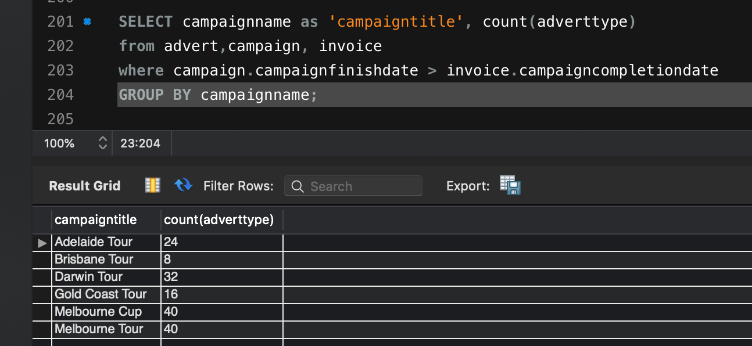**Question 2**

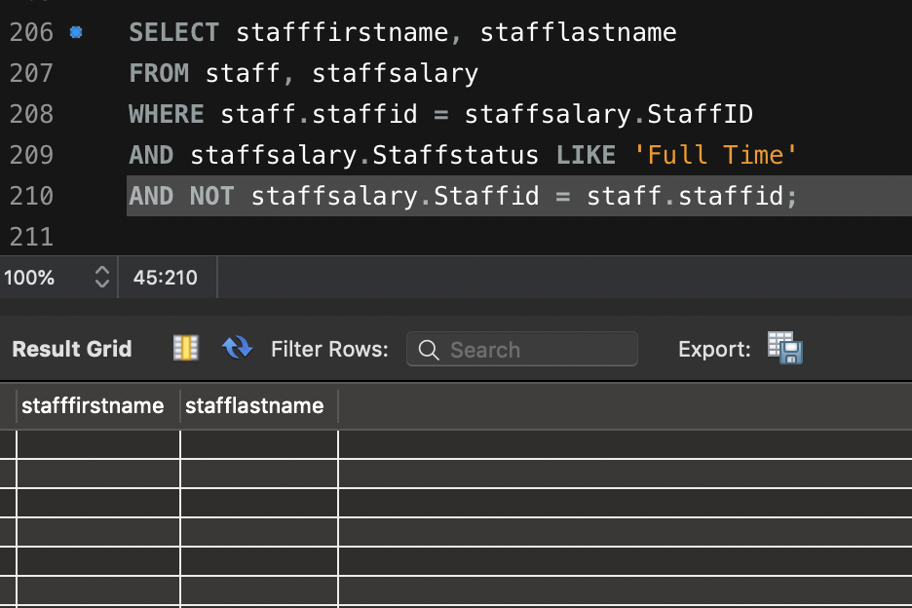**Question 3 (Assume that all Fulltime staff were managers of the campaigns they worked on)**

**Question 4 (Assume that all campaigns did not have more than two staff members working who had a salary grade greater than 2)**

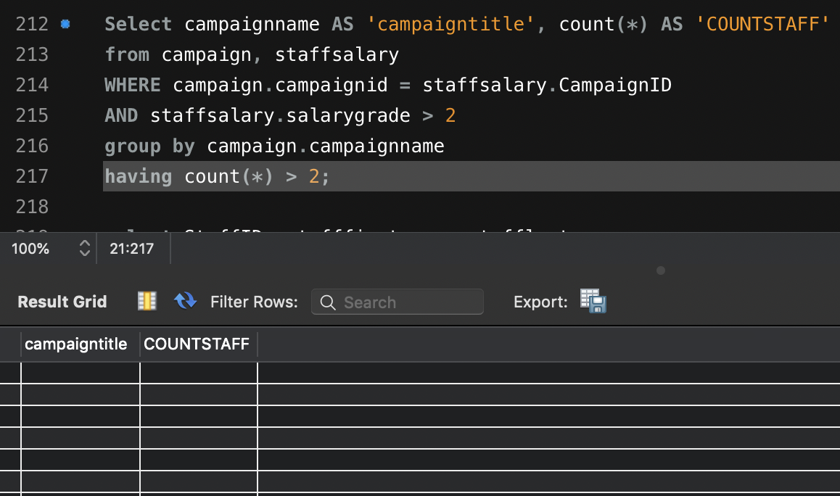

**Question 5**

